2015 - 2016 HYAA Wrestling

The HYAA Wresting Team experienced a banner 2015 -2016 season. The Novice clinic, which kicked off in October 2015, primed the pump at the very beginning of our season by introducing 18 new wrestlers to the sport. Overall 25 kids participated in the clinic.
Many of the novice clinic wrestlers decided to pursue the sport by then enrolling in the HYAA regular season where we had a record number of registered children.
We competed in two leagues again this year; the Jersey Shore Junior Wrestling League (JSJWL) which comprised of teams from both Monmouth and Ocean counties and the Mid-Jersey Wrestling League (MJWL) which comprised of teams from Monmouth and Middlesex Counties.
The team practiced hard every Tuesday and Thursday from 6:00 pm to 7:30 pm. The season concluded in late February with tournaments in both leagues.
Jersey Shore Junior Wrestling League
Our HYAA wrestling team wrestled in JSJWL “B” Division’s Patriot League where we were 11-4 overall for the season and 4-3 within the tougher B division. Despite not wrestling a full line-up and having several forfeits, all the boys that did compete, competed to win every match. In the matches we fell short, forfeits were key so we look to continue the growth of our team to fill any empty roster spots as we continue to strive for the championship.
The team’s “B” Division playoff hopes came down to beating Matawan and it was a rumble from start to finish. The teams went back and forth trading bouts throughout the morning and the match came down to the final few weight classes. When it was all said and done, Holmdel won and was headed to the playoffs! Our team then headed into the “B” Division Patriot League playoffs where we finished in fourth place.
In the year end JSJWL Individual Tournament, Victor Wladika won the “B” division heavy weight class while two other wrestlers: AJ Fernandez (64 lbs) and Thomas Ammirati (122 lbs) where close second place finishers. Michael Todisco (52lbs) had a great day and finished in third places. Nicky Ammirati (95 lbs) and Luke Dupont (107 lbs) came in an impressive fourth place while Brian Frothingham (68 lbs) earned fifth place. The day was rounded out by Anthony Paulino (60 lbs), AJ Todisco (72lbs) and Chris Bell (150 lbs) who all earned sixth place finishes. Overall it was a great day for the entire team. As the heavyweight champion of the “B” Division, Victor Wladika went on to compete in the league's “Civil War” Match which pits the winner of the “A” Division title against the winner of the “B” Division title. Vic would represent Holmdel well and won a hard fought battle to earn his spot on the Jersey Shore All Star team as the teams Heavyweight champion!

Mid Jersey Wrestling League
Our third year in the MJWL league was a great experience. MJWL is a 6th grade and under league and ran concurrently with the JSJWL season giving our younger wrestlers plenty of opportunity to compete on different levels. The boys wrestled in both the “A” and “B” divisions of the MJWL.
In the MJWL individual “A” division tournament we crowned a champion in Luke Dupont in the 110 lb weight class. Thomas Cleary (85 lbs) came in an impressive second and Jaden Gallo (90 lbs) rounded out the day with a well earned third place.
It is now three years in a row that we have had multiple wrestlers in the finals and crowned a champion. The team as a whole finished in fifth place out of sixteen teams. We were just a couple of points shy of winning the fourth place trophy.

Team Support and Marketing
Lori Ammirati continued her role organizing the snack table for the JSJWL team during our home matches arriving early to set up and staying late to break down the table. Dana DuPont continued her role as Team Manager, helping organize match data and keeping the parent’s informed regarding practices, matches and tournaments. This is their sixth year supporting the team. Christina Reyes organized the snack tables for our home MJWL meets. Isabella Pinnero continued her role for a fourth year as the JSJWL match score keeper.
The Wrestling Promotions team lead by Gloria Vanderham and Amy Cleary continued its success with multiple events during the season. This is Gloria’s second year leading the marketing effort. The Marketing team is comprised of dedicated volunteer parents who initiated a wide array of promotional events aimed at driving increased team participation and broadening community awareness of the sport. Promotion projects included a reprise of Holmdel wrestling car magnet program, lawn signs to promote registration, a team photo night, new coordinated warm ups, multiple articles in local publications such as Patch and the Holmdel Journal and a very successful Parent’s Night Out.
The annual HYAA Wrestling Awards Banquet was held on April 7th at Indian Hill School. This year we hosted a record 160 parents and children. Individual and participation trophies were awarded to the team. The first annual HYAA Wrestling Scholarship was also given to Garret Hilsheimer for his career success starting within our HYAA Wrestling program and continuing in the Holmdel High School wrestling program where he finished his career with District 21 title as a high school senior! Garret is the Holmdel High School’s first District Champ in 18 years proving our HYAA wrestling program is paying dividends at the High School level. We are confident that Garret has started a streak that will be continued by other high school wrestlers who came out of our HYAA program.

Spring Clinic
HYAA will conduct a Spring Wrestling Clinic beginning April 8th and ending on June 17th, 2016. Practice will be from 6:00 pm to 7:30 pm on Friday nights with all boys K thru 12th grade welcomed. The clinic is designed to stress basic wrestling technique as well as strength and conditioning training so we can continue the progress our team has made during the regular season.

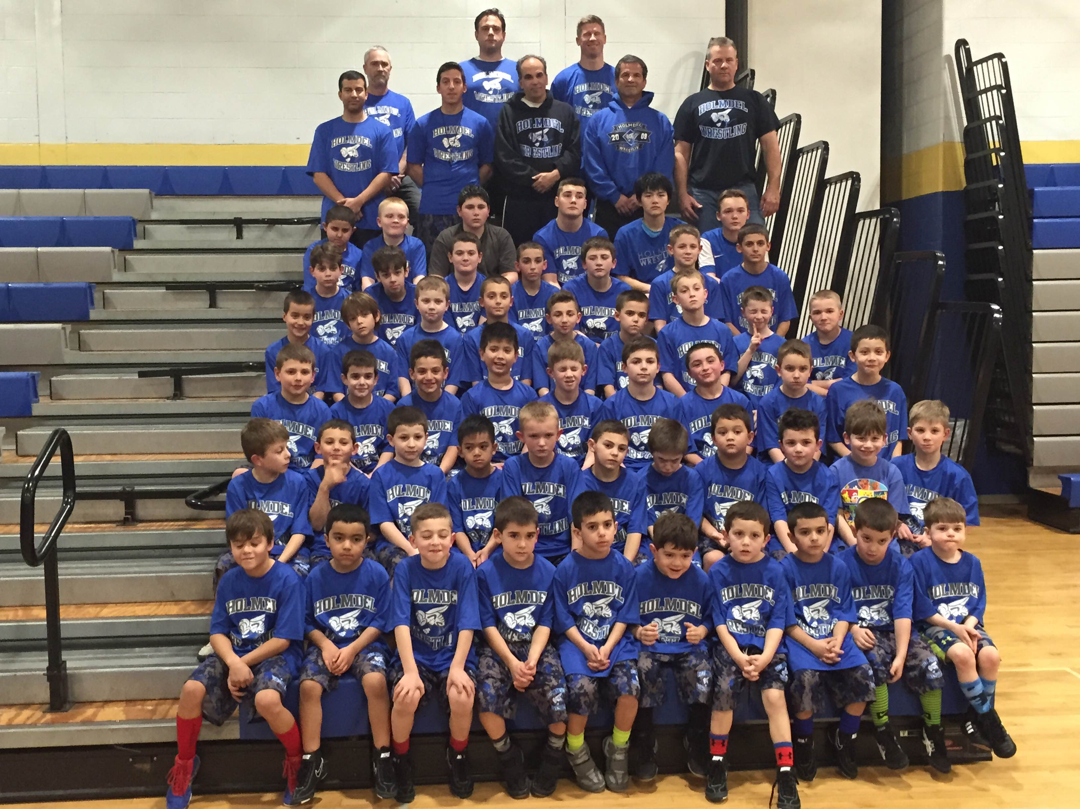
 |  |  | Coach Billy Greiner | Coach George Lazarou | Coach Michael Cleary
 |  | Coach Steven DeJesus | Coach Orlando Reyes | Coach Andrew Pinnero | Head Coach James Ilvento | Coach Scott Dupont
 | David Solyman | Rowan Hodges | Joesph Mancino | Victor Wladika | Tommy Gao | Ethan Hodges
 | Brandon Mancino | Matteo Pinnero | Luke Dupont | Brian Frothingham | Nick Ammirati | Thomas Cleary | Jaden Gallo
Michael Scagnelli | Colin Sharpe | Billy Greiner | Jack Podesta | Anthony Paulino | Frankie Boardwick | Zach Rabkin | Nicholas  Paulino | James Vanderham
Kyle  Rosen | Michael Todisco | Alex  Reyes | Dimitri Lazarou | Jack  Cleary | AJ  Todisco | AJ Fernandez | Robert Mioduszewski | Adam Azzoui
Markus Cermelli | Carter Dailey | Michael Langman | Jason Rualo | Rowen Blackmore | Justin Dailey | Lucian Khachaturian | Jeremy Dulow | Preston Dowd | Maxim Gulko | Mathew Cleary
Luke Podesta | Steven Dejesus | Michael  Paulino | Dylan Placca | Christian Reyes | Justin Piscopo | Liam Azzoui | Adam Olsen | Anthony Scagnelli | Logan Placca
Not pictured | Thomas Ammirati | Trey Tulenko | Jackson Gordon | Lucas Gordon | Benjamin Gordon | Thomas Ilvento | Chase Grimando | Christian Rebimbas | Declan Jackman | Chris  Bell
Not pictured | Quinn Pavlinetz

